*LAB # 02*

FILE ACCESS PERMISIION IN LINUX

# *OBJECTIVE:*

*To study the various File Access Permission and different types users in LINUX*

*LAB task*

1. ***Create multiple files and perform all commands.***

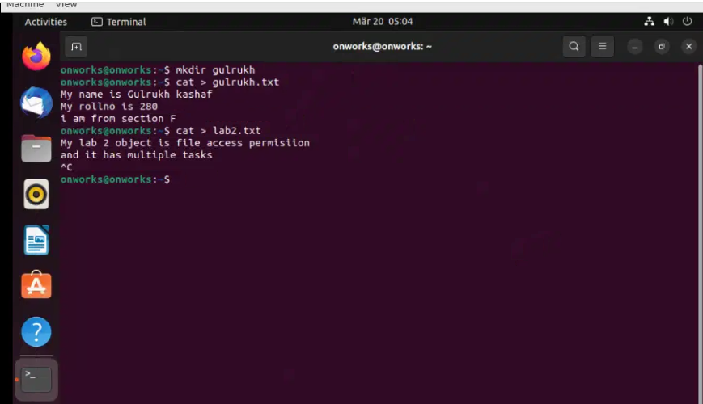

* ***Ls –l***

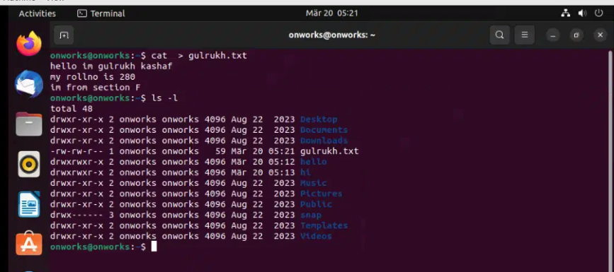

* ***Ls –a***

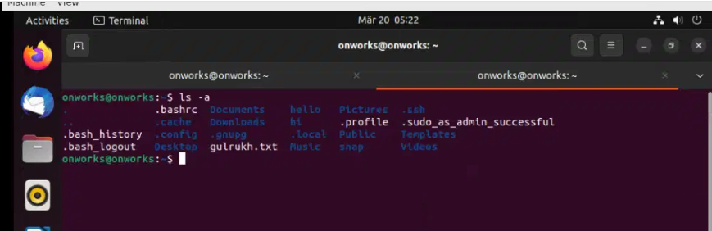

* ***Ls –p***

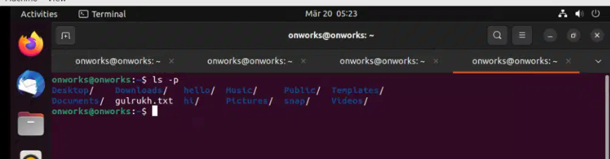

* ***Ls -f***

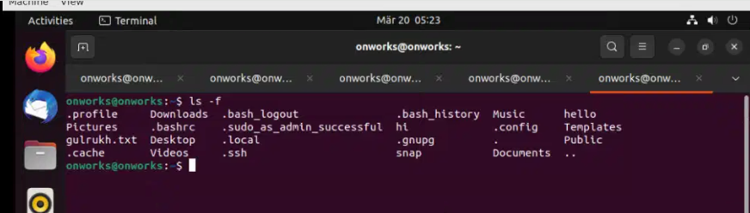

* ***Ls –R***

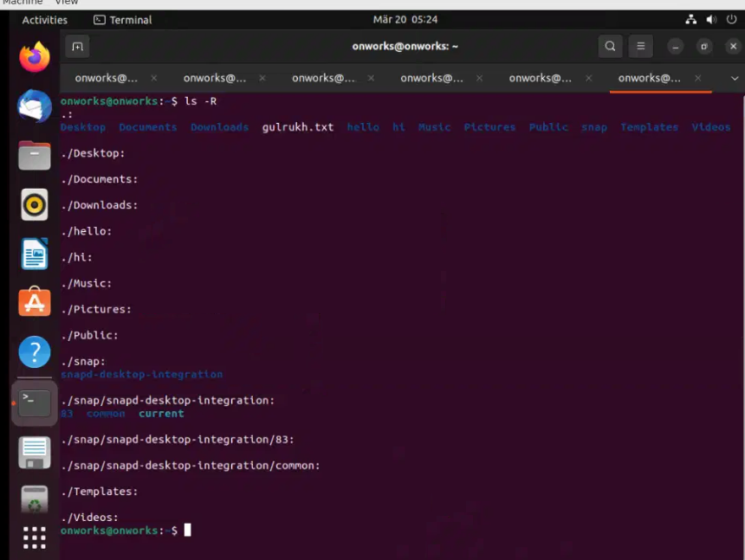

1. ***Remove non empty directory.***

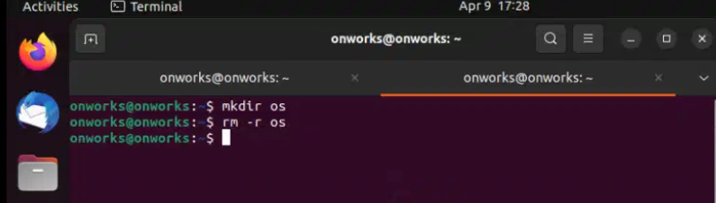

1. ***date (for Current Date).***

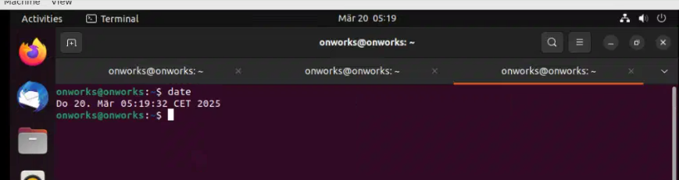

1. ***ps***

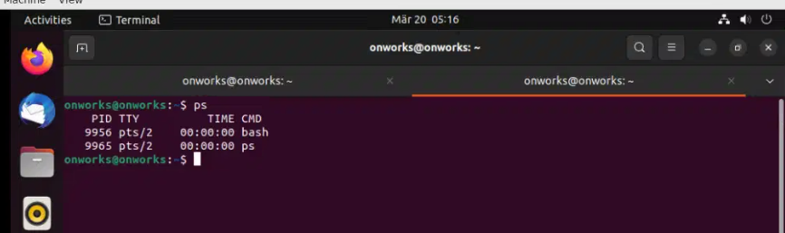

1. ***finger***

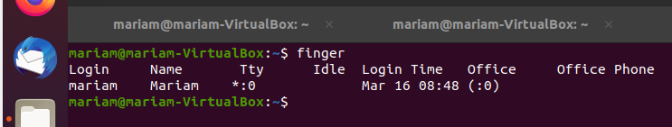

1. ***cal (For Calender).***

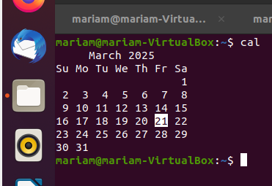

***7. free***

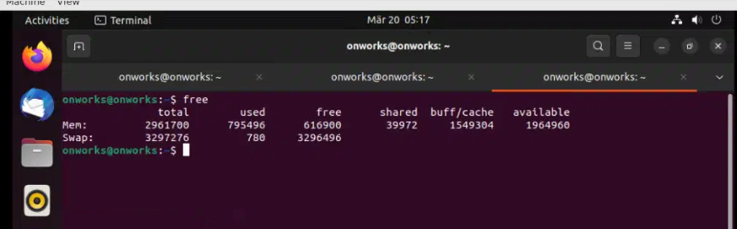

***8. Create a file name which displays the contents of currentyear.***

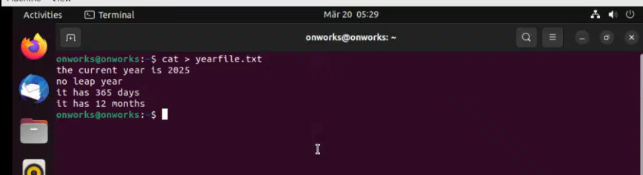

***9. Display calendar and date simultaneously.***

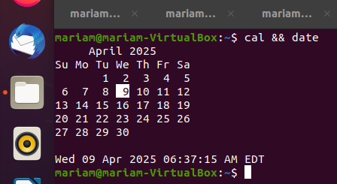

***10. df./***

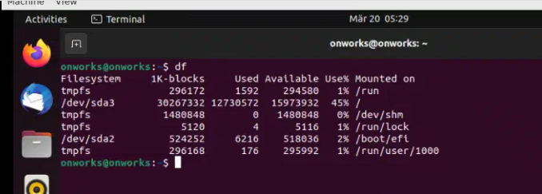

***11. df –k./***

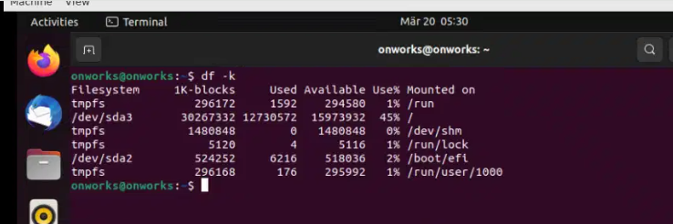

***12. du –s\****

